# Brainstorm

**TIP**

You can select a sticky note and hit the pencil [switch to sketch] icon to start drawing!

### Before you collaborate

##### A little bit of preparation goes a long way with this session. Here’s what you need to do to get going.

###### 10 minutes

**1**

### Define your problem statement

##### Predicting forest fire using an appropriate computer vision technique and to inform local fire authorities to reduce the impact

###### 5 minutes

**2**

### Brainstorm

##### Write down any ideas that come to mind that address your problem statement.

###### 10 minutes

**3**

### Group ideas

##### Take turns sharing your ideas while clustering similar or related notes as you go. In the last 10 minutes, give each cluster a sentence-like label. If a cluster is bigger than six sticky notes, try and see if you and break it up into smaller sub-groups.

###### 20 minutes

**4**

### Prioritize

##### Your team should all be on the same page about what's important moving forward. Place your ideas on this grid to determine which ideas are important and which are feasible.

**20 minutes**

Use of Agile methodology to implement this project

### After you collaborate

You can export the mural as an image or pdf to share with members of your company who might find it helpful.

**Quick add-ons**

# & idea prioritization

**PROBLEM**

Predicting forest fire is not always accurate so we need a consistent approach to do so

**A Team gathering**

Define who should participate in the session and send an

MANIKANDAN V

**TIP**

Add customizable tags to sticky notes to make it easier to find, browse, organize, and categorize important ideas as themes within your mural.

**Low-cost smart system of networked nodes, can be based of narrow beam Far Infrared (FIR) sensors, which can detect and locate strong heat sources, such as fire, in real-time**

Creating a backup database to store live feed of forest fires

Creating a communication plan to inform local fire authorities

Forest fire detection using YOLO- based CNN Model

**CHANDRUR**

Datasets can be obtained from Kaggle

MANIKANDAN V

**CHANDRU R**

**Use of the open source Setup of server**

1. Share the mural

invite. Share relevant information or pre-work ahead.

**Near Real Time (NRT) data provided by the**

Deployment of model to cloud

To develop a pragmatic approach to addressing seemingly conflicting objectives of forest fires.

*Implementation ofweb- applicationto recognisethe videofeed images*

*Toimportthe layereddatasetand comparethe capturedimages withdataset configurations*

Use of the open source Near Real Time (NRT) data provided by the active fire map of Fire Information for Resource Management System

Datasets can be obtained from Kaggle

Datasets can be obtained from Kaggle

Use of Decision Tree algorithm to determine forest fire and compare it with other algorithms.

IoT based forest fire detection system.

*Principleofmulti-modal mixtureGaussian backgroundmodelcanbe usedtoestablisha backgroundmodelto extractthebackgroundof theearlyforestfiresmoke video*

*Selectionofsuitable appropriaterouting protocaltotransfer andrecognisevideo feedondetectionof forestfire*

*Objectdetectionmethod (CNN),insteadoftowers setupandsatellitebased monitoring,wecanuse livevideofeedfroman UnmannedAerial vehicle(UAV)*

**rooms for monitoring of**

Approaches

Dataset related ideas

**Share a view link** to the mural with stakeholders to keep

Use this template in your own

**active fire map of Fire**

**Information for Resource captured video**

**Management System feed**

Creating a centralized system to input multiple input feeds to detect several forest fires at once

In case of forest fire detection the detection area is acknowleded to the servers

IoT based forest fire detection system.

Object detection method (CNN), instead of towers setup and satellite based monitoring, we can use live video feed from an Unmanned Aerial vehicle(UAV)

them in the loop about the outcomes of the session.

**B Set the goal**

**Salient object detection (SOD)**

**Use of Agile**

## brainstorming sessions so your team

**and burned area methodology**

**segmentation to implement**

1. **Export the mural**

## can unleash their imagination and start shaping concepts even if you're not sitting in the same room.

**10 minutes** to prepare

**1 hour** to collaborate

**2-8 people** recommended

Deployment of model to cloud

Think about the problem you'll be focusing on solving in the brainstorming session.

1. Learn how to use the facilitation tools

Use the Facilitation Superpowers to run a happy and productive session.

[**Open article**](https://support.mural.co/en/articles/2113740-facilitation-superpowers)

**Key rules of brainstorming**

Use of Agile methodology to implement this project

Setup of server rooms for monitoring of captured video feed

Creating a backup database to store live feed of forest fires

To run an smooth and productive session

**(BAS)**

In case of forest fire detection the detection area is acknowleded to the servers

Implementation of web- application to recognise the video feed images

Use of YOLO- based CNN for forest fire detection

Salient object detection (SOD) and burned area segmentation (BAS)

**this project**

Salient object detection (SOD) and burned area segmentation (BAS)

Use of Decision Tree algorithm to determine forest fire and compare it with other algorithms.

To import the layered dataset and compare the captured images with dataset configurations

Creating a backup database to store live feed of forest fires

Use of YOLO- based CNN for forest fire detection

#### Measures for mitigation/communication with authorities

Export a copy of the mural as a PNG or PDF to attach to emails, include in slides, or save in your drive.

### Keep moving forward

Strategy blueprint

Define the components of a new idea or strategy.

[Open the template](https://app.mural.co/template/e95f612a-f72a-4772-bc48-545aaa04e0c9/984865a6-0a96-4472-a48d-47639307b3ca)

**Customer experience journey map**

Stay in topic. Defer judgment.

Selection of suitable appropriate routing protocal to transfer and recognise video feed on detection of forest fire

Encourage wild ideas. Listen to others.

### Importance

To develop a pragmatic approach to addressing seemingly conflicting objectives of forest fires.

Creating a communication plan to inform local fire authorities

If each of these tasks could get

Understand customer needs, motivations, and obstacles for an experience.

[Open the template](https://app.mural.co/template/b7114010-3a67-4d63-a51d-6f2cedc9633f/c1b465ab-57af-4624-8faf-ebb312edc0eb)

Creating a centralized system to input multiple input feeds to detect several forest fires at once

Go for volume. If possible, be visual.

done without any difficulty or cost, which would have the most positive impact?

Strengths, weaknesses, opportunities & threats

Identify strengths, weaknesses, opportunities, and threats (SWOT) to develop a plan.

[Open the template](https://app.mural.co/template/6a062671-89ee-4b76-9409-2603d8b098be/ca270343-1d54-4952-9d8c-fbc303ffd0f2)

**TIP**

Participants can use their cursors to point at where sticky notes should go on the grid. The facilitator can confirm the spot by using the laser pointer holding the **H key** on the keyboard.

[Share template feedback](https://muralco.typeform.com/to/CiqaHVat?typeform-source=app.mural.co)

[**Share template feedback**](https://muralco.typeform.com/to/CiqaHVat?typeform-source=app.mural.co)

### Feasibility

Regardless of their importance, which tasks are more feasible than others? (Cost, time, effort, complexity, etc.)

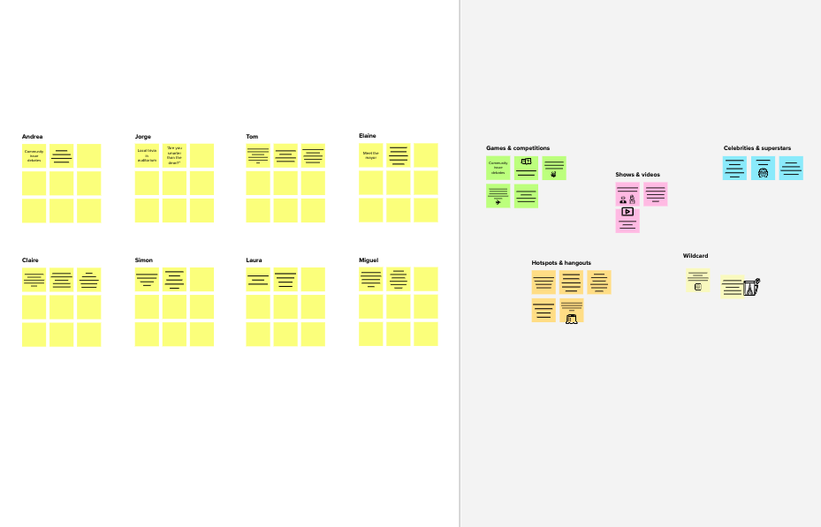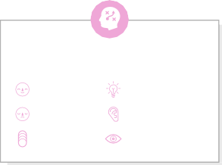

**Template**

**Need some inspiration?**

See a finished version of this template to kickstart your work.

[**Open example**](https://app.mural.co/template/e5a93b7b-49f2-48c9-afd7-a635d860eba6/93f1b98d-b2d2-4695-8e85-7e9c0d2fd9b9)